**Financial Forecasting**

OUTPUT SCREENSHOT

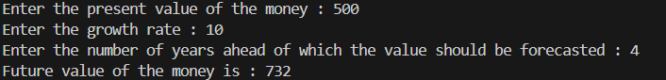

CODE ANALYSIS

There are 2 classes in the code.

* financialForecast class which contains the static recursive method for calculating the future value (FV) of a sum of money (PV) according to the growth rate (r) for a number of years (n) as
$$FV=PV×{(1+r)}^{n}$$

* Demo class which contains the main method and commences the execution of the code.

The base case in the recursive method is when number of years becomes 0. In the recursive case, the present value of the money is calculated for each consecutive year based on the present value of the money in the past year by availing recursion.

INFERENCE

Time complexity of the recursive method = O(n)

However, recursion maintains a call stack, thus, requiring more space in the memory.

Thus, while keeping the time complexity same, if we want to reduce the space complexity of the algorithm, we can use an iterative approach where we run a loop for every value from 1 to the number of years and multiplying the present value with (1+growth rate) to obtain the future value of the money.